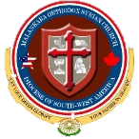
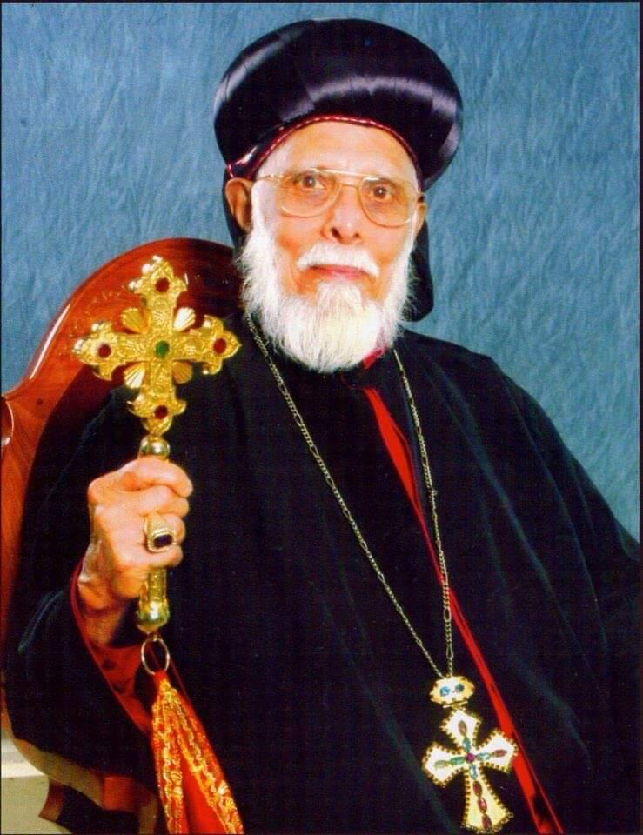
Malankara Orthodox Syrian Church
Diocese of South-West America
Mar Makarios Scholarship Award
3101 Hopkins Rd, Beasley, Texas – 77417
Email: marmakariosscholarship@gmail.com

2024 Application Form

- Applicant Information

Full Name:
Mailing Address:
City: | State: | Zip Code:
Email Address: |  | Phone Number:
Home Parish Name & Address:
Parish City: | Parish State: | Parish Zip Code:
Home Vicar’s Name: |  | Home Vicar’s Phone:
Home Vicar’s Email Address:

- Education

College Name & Address:
College City: | College State: | College Zip Code:
GPA:
Applicant’s Signature: |  | Date:

DOCUMENTS TO BE SUBMITTED ALONG WITH COMPLETED APPLICATION FORM
1. Copy of transcript from the College showing minimum GPA of 2.7.
2. Recommendation letter from the Vicar.
3. Recommendation letter from College / Internship / Volunteering Reference.
4. An essay on "Orthodox Christianity and Mental Health: Addressing the Needs of Youth" by the Applicant.

SUBMISSION & DEADLINE BY March 9, 2025
Application shall be submitted to the aforementioned email as a singular electronic document with the subject titled “[Full Name of Applicant] - Mar Makarios Scholarship Application”. An email acknowledgment will be sent upon the receipt of the application.

RULES & GUIDELINES

A. ELIGIBILITY
- The Applicant shall be a member of a family in good standing of a Parish in the Diocese of South-West America.
- The Applicant shall be a successful graduate from a college, in 2024 that is recognized by the respective State in the USA. NO APPLICATIONS WILL BE ACCEPTED FOR STUDYING OUTSIDE USA
- The Applicant shall submit the completed application along with all the required documents, specified in this form on or before the deadline set by the Award Committee, in the application form.
- Incomplete application will not be eligible for Awards.

B. APPLICATION
The applicant shall complete the official application form accurately and send it to the Award Committee (marmakariosscholarship@gmail.com) before the deadline, along with the following documents:
- A copy of the college transcript, clearly showing the GPA from the applicant’s college in the US.
- A recommendation letter from the Vicar of the parish that the applicant attended during their degree showing regular attendance in the church services, participation and involvement in church activities and spiritual organizations, such as MGOCSM, Youth Movement/FOCUS, Church choir, Services in the Altar, etc. The letter shall include a certification of the Applicant’s character and leadership abilities along with the allegiance to the orthodox faith and the church. The Vicar shall fill the Vicar Recommendation form and shall send it to the Award Committee.
- A recommendation letter from a(n) Professor / Official / Community Leader, showing the Applicant’s community involvement, volunteer services, charitable works, sports and athletic activities, any other extracurricular activities and leadership capabilities. The Professor/Official/Community Leader shall fill the Recommendation form and it shall be enclosed with the application.
- A personal essay on “Orthodox Christianity and Mental Health: Addressing the Needs of Youth” (minimum 500 words, size 12 font size, 1.5 line spacing) by the Applicant. This essay should examine challenges and suggest practical solutions for retaining our youth within the church.

C. EVALUATION & SELECTION
- The Award Committee is responsible for preparing the evaluation guidelines and worksheet.
- Out of the total scores for evaluation, 60% will be based on graduation cumulative GPA and 40% will be based on the involvement in Extracurricular Activities, the Recommendation Letters and the personal essay.
- The application and the supporting documents will be evaluated by the Award Committee.
- No immediate relatives of the applicants should fill the recommendation forms (if the immediate relative of the applicant is the official, then the next official should fill the same and the reason for it should be mentioned).
- The decision of the Award Committee with the consent of the Diocesan Metropolitan will be the final.
- The results will be communicated to all the Parishes in the Diocese through a Kalpana from the Diocesan Metropolitan.
- The results will also be published on the Diocesan Website.
- The Award Committee will reach out to the applicant for any additional information, if necessary.

 | Documents to Submit | SUBMITTED (Y / N)
 | Official Transcript(s)
 | Recommendation letter - Vicar
 | Recommendation letter - College Official
 | Personal Essay

DEADLINE: MARCH 9TH, 2025

